Level Design Document

Part I: Initial Tutorial Level

Tutorial Format

There are a total of four short tutorial levels, each presenting small challenges at a slow pace, to allow the player to get accustomed to the gameplay. The player will have free reign over all the controls. The player will not be stopped or interrupted if he/she chooses to ignore the tutorial hints. The player can stay in the tutorial level for as long as he or she wishes, and may return at any time to practice using the controls in a relatively safe environment.

Player Assumptions

The tutorial assumes that the player will immediately identify the character in the center of the screen as himself or herself. It also assumes that the player can recognize the top-down perspective of the game and navigate accordingly.

Tutorial Objectives

1. **Teach the player how to ping:** Ping is a player control unique to this game, so it should be the first thing covered in the tutorial. The tutorial also identifies the energy bar that shows the player how many more pings he or she can use.
2. **Teach the player how to navigate (walk):** Most players will already be familiar with the arrow key movement controls, but the tutorial should cover it for clarity.
3. **Teach the player how to navigate (run):** Running is the faster but riskier alternative to walking. It will be introduced fairly early in the tutorials but will be introduced after walking. Users need to master walking first before they can learn to fully appreciate the utility tradeoffs when running.
4. **Show the player how levels are completed:** There should be a clear point in the tutorial level that alerts the player that he or she has reached the end of the level. This point, characterized by distinctive visual or audio cues, should be representative of the goal point in future levels.
5. **Teach the player that critters are harmless:** Critter type monsters cannot harm the player in any way, but are important for other interactions such as recharging (see Objective 5). Learning that critters are harmless will give the player ease of mind when encountering critters, initially.
6. **Teach the player to be wary of hunters:** The player will learn to avoid hunters, which will chase the player if he/she makes noise nearby. Hunters will instantly kill the player upon contact.
7. **Teach the player how to recharge through monster pings:** Recharging ping energy will be crucial in large levels where ping energy could be exhausted quickly. The player will learn that if he/she is in the vicinity of a monster ping, then his/her ping energy will be recharged.
8. **Introduce the player to landmark checkpoints:** The landmark in the tutorial should be placed such that the player will already recognize it, should they die at any point in the tutorial. The landmark is a checkpoint that the player will always be able to see.

Tutorial Storyboards

The tutorial is designed to be simple and direct. Levels are relatively small and minimalistic. However, they are designed such that the player will have to learn the mechanics and interactions introduced in each level in order to progress further. Experienced players should be able to complete through it very quickly. Menu boxes at the beginning of each tutorial level introduce the player to game mechanics and interactions. Additionally, the tutorial levels include help text that appears when a player encounters something new, and explain what the player should do.

Level 1: Orientation (Objectives 1, 2, and 4)

This is a simple level that covers pinging, navigating and how to win the level (first, second and fourth objectives). The main purpose of this level is to introduce the player to navigating in the darkness. The goal is very near to the player’s starting position, making the level very short. This is to prevent the player from running out of ping energy before finding the goal.

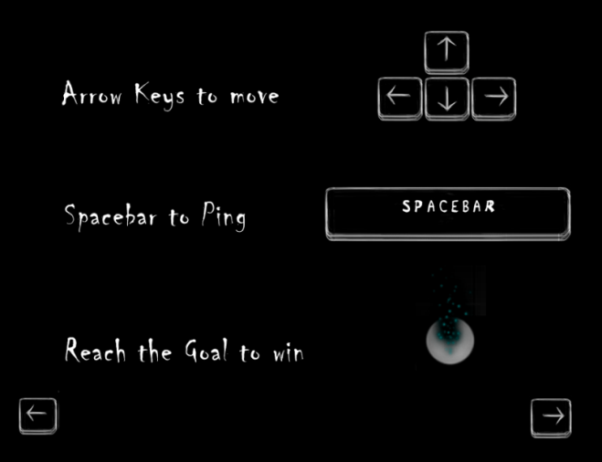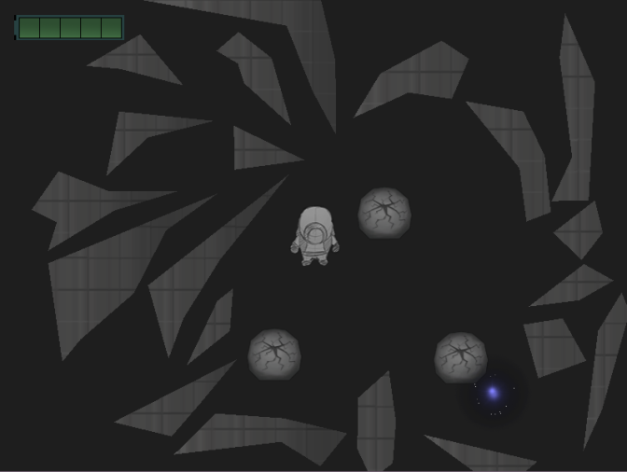

Reach Aria to complete the level



Level 2: Familiarity (Objectives 3 and 8)

This level covers the third and eighth objectives, running and landmarks. This level includes a long tunnel which will encourage players to use the running controls (as it is faster). There are also landmarks in the tunnel which must be discovered in order for the player to complete the level (as the player has to travel through the tunnel to get to the goal). When landmarks are discovered help-text pops up to further explain them.

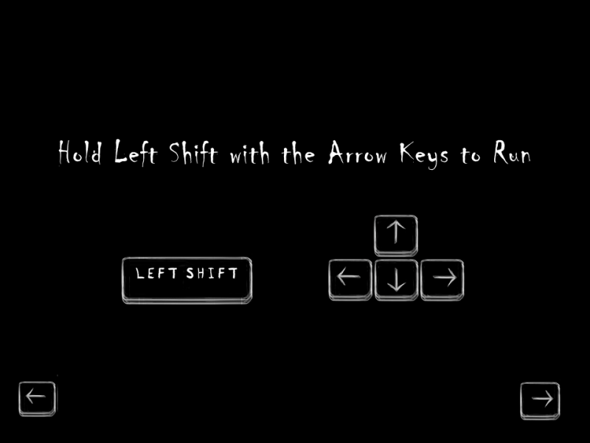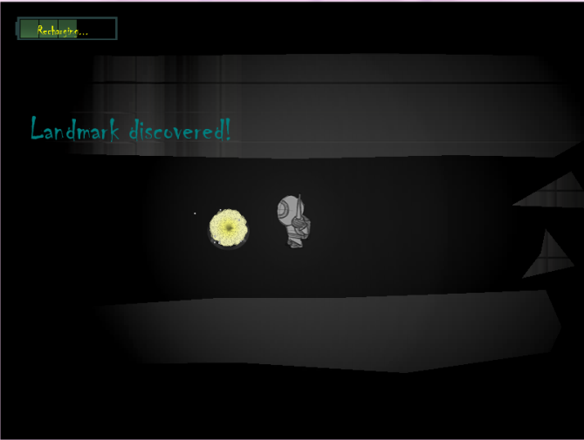

Level 3: Not Alone (Objectives 5 and 7)

This level covers the fifth and seventh objectives, critters and recharging from monster pings. Hunters are not yet introduced because the player needs to become comfortable with the idea of recharging energy from monsters.

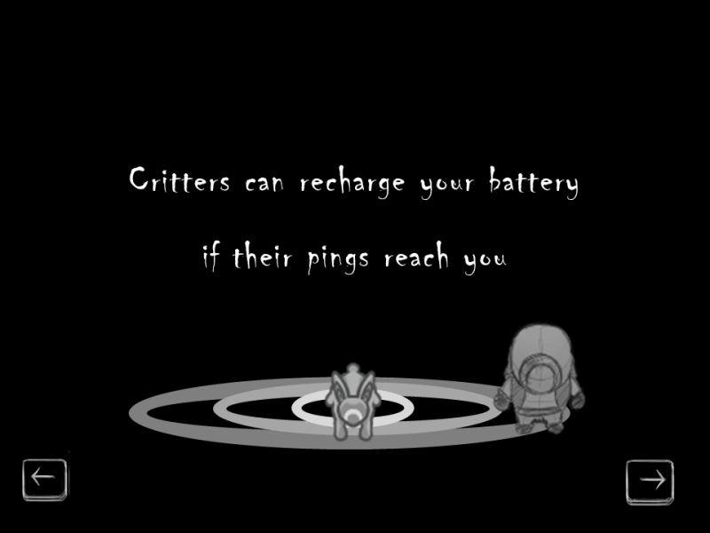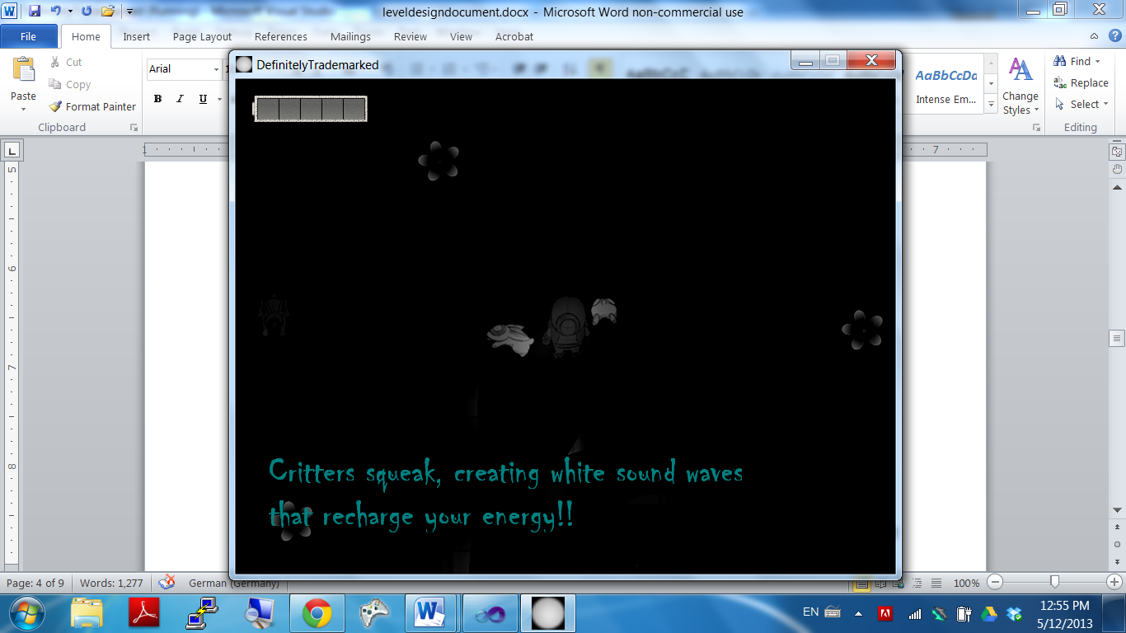

Level 4: Danger Lurks Beyond (Objective 6)

This level covers the fourth objective, hunters. The player can die in this level, which sets him or her back to the beginning of this level and instills a sense of fear. Critters also exist to allow the player to use what he or she learned in the previous level to recharge his or her ping energy.

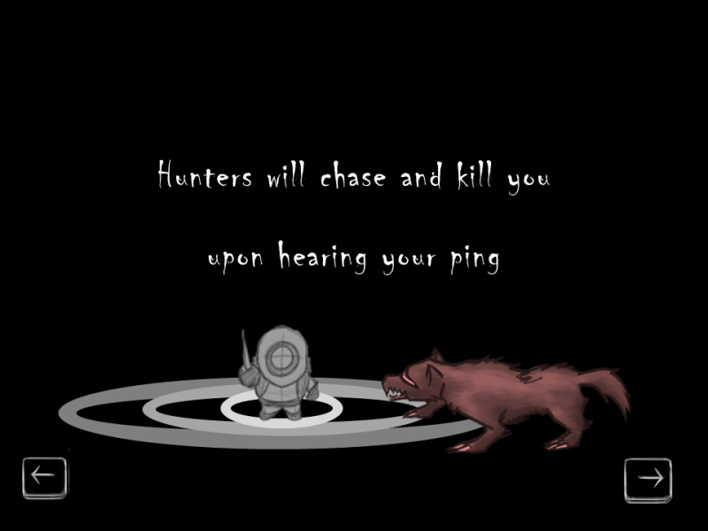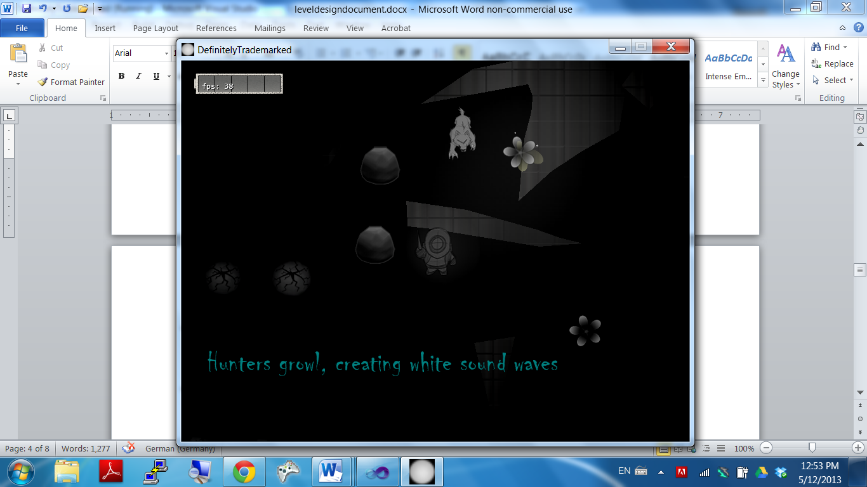

Part II: Intermediate Levels

Individual Challenges

Intermediate levels closely resemble the tutorial level, but with greater challenges and no hint dialogue. For example, an intermediate level might consist of the following three challenges:

Challenge 1: Low Energy

This region is full of obstacles, but few critters to restore battery power. Strategic ping management is heavily stressed. Players might even need to restore power from enemy pings to avoid complete darkness. Players will have to carefully ration the number of pings they use while keeping in mind that an encounter with a monster in the dark means certain death. Players will become aware of the need to conserve energy when they observe that there are little to no critters in the vicinity.

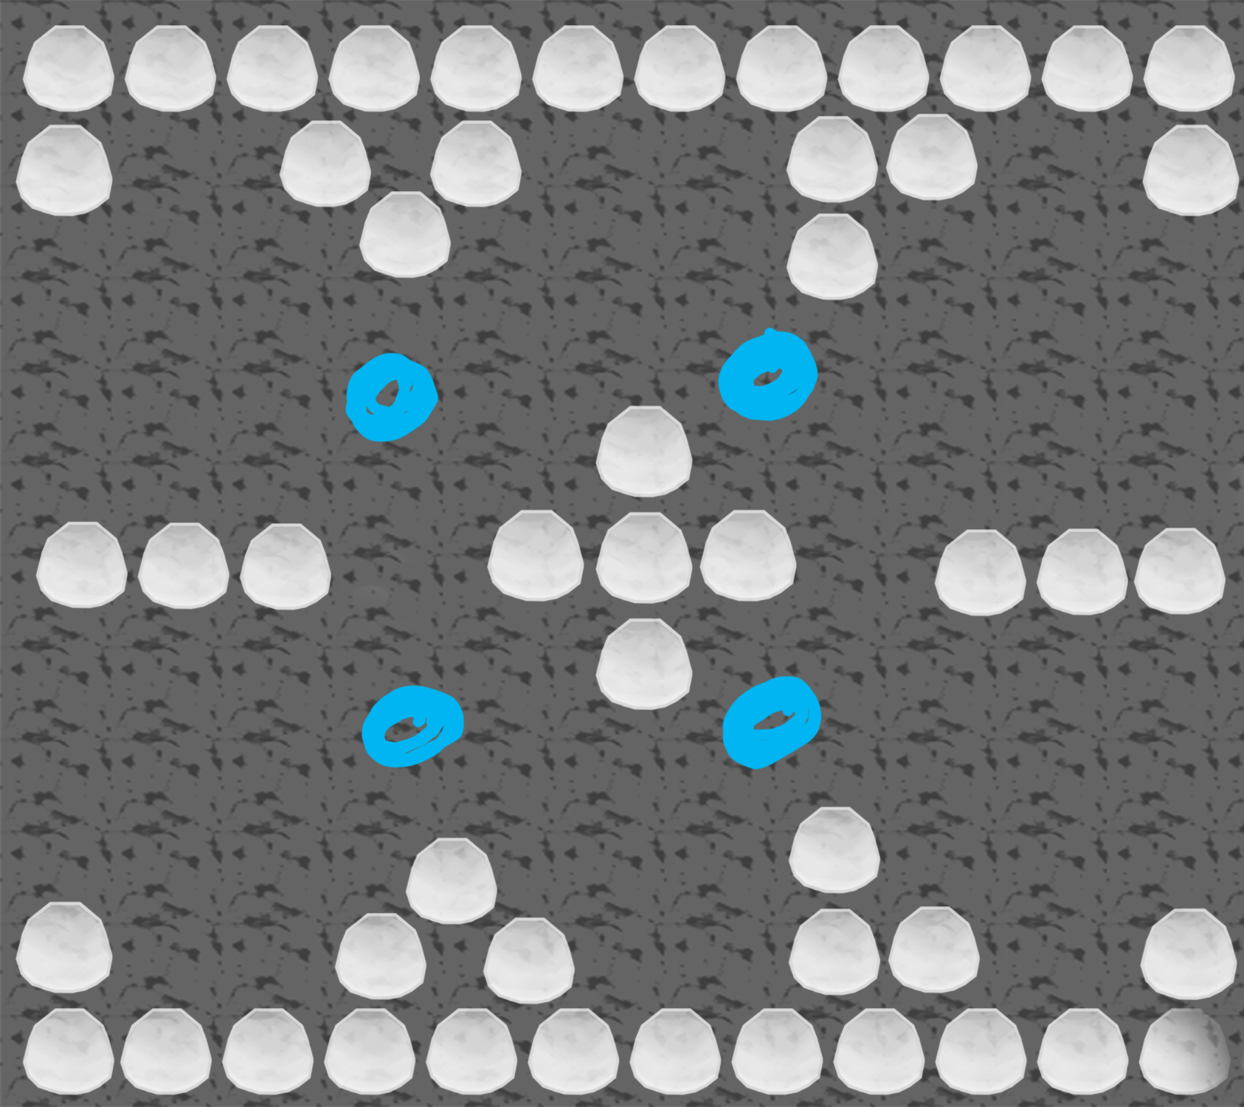

The player is best off pinging only in one or two of the blue-dot locations pictured above. If the player still runs out of ping energy, the next option would be to run back and forth repeatedly or find an enemy and play chicken.

Challenge 2: Strategically Located Enemies

Campers are monsters that hover around a pre-designated area and do not leave the area. Campers waiting in ambush might be placed in hard to avoid areas such as dead ends, but will not leave their territory. The topography of the level obstacles combined with strategic enemy placement will challenge players to survive monster encounters by thinking carefully before embarking on any course of action. Players must also be able to adapt quickly to dangerous situations to escape.

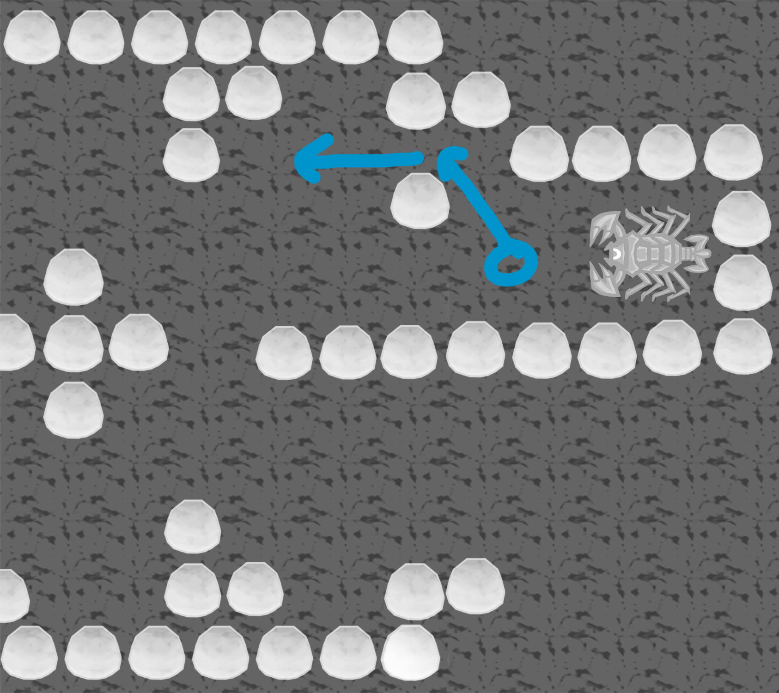

In this example, the player should follow the blue path, where the camper cannot fit, until the player is out of the camper’s range of movement.

Challenge 3: Interactive Level Elements

Intermediate levels have interactive elements that react when a player pings or bumps into them. One such example is a secret passage blocked by a breakable wall that a player must find and destroy before continuing.

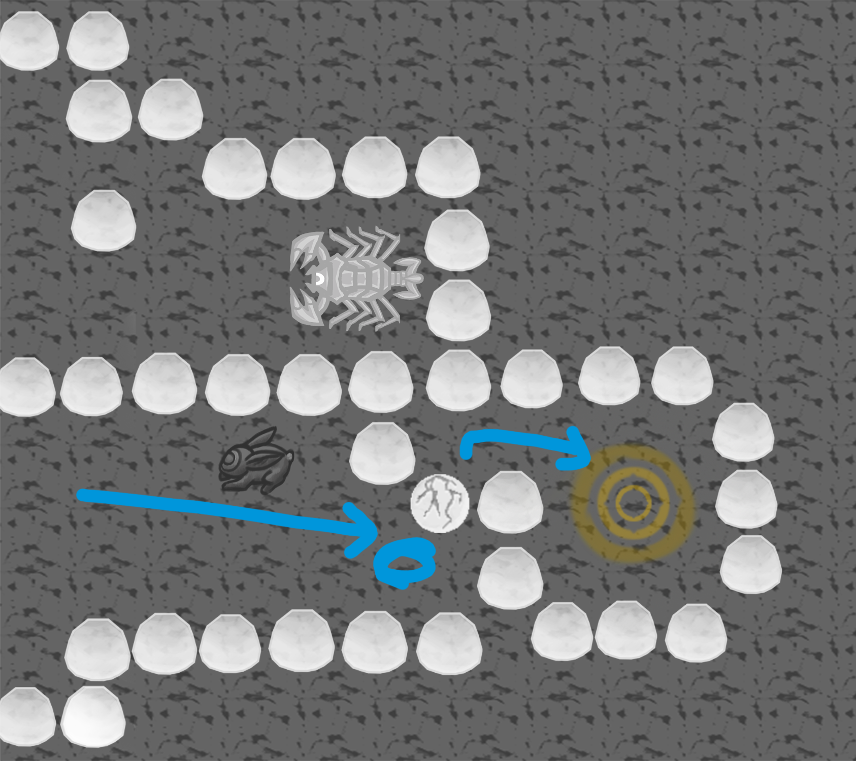

In this example, the player should follow the blue path and ping in front of the breakable wall. If the player is low on ping energy, he/she should take advantage of a nearby critter, or run back and forth to slowly recharge energy in hopes that enemies won’t be nearby.

Intermediate Level Storyboard

The sample level described above should be played as follows:

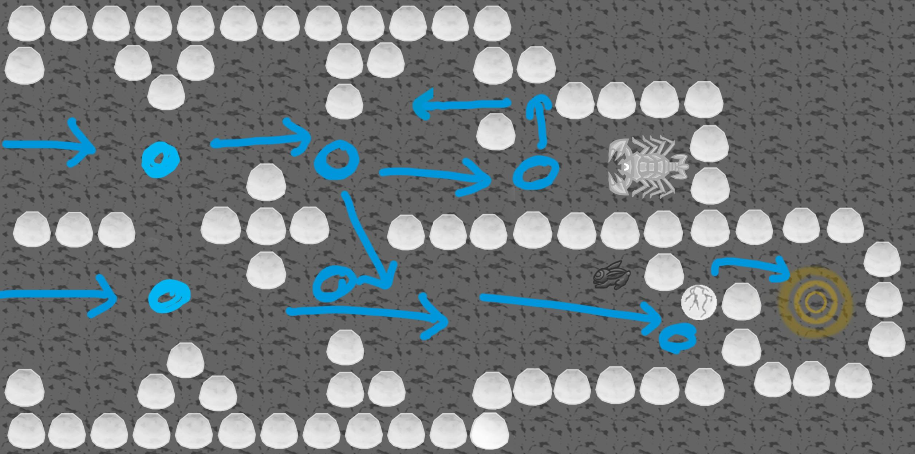

Starting on the left, the player can take any of the blue arrows to the goal, pinging at the blue dots. Note that an actual level might be much larger. The size of this map is only for document purposes to show how a level might work.